
version 0.1
YT9218N Sample Delivery Instructions

September 25, 2023
Motorcomm Electronic Technology Co.,Ltd.
202, 2nd Floor, IC Innovation Center, 78 Jinshan East Road, Suzhou High-tech Zone.
Building 18, Lane 388, Shengrong Road, Pudong New Area, Shanghai.
www.motor-comm.com
Copyright Statement
This document is copyright of Motorcomm Electronic Technology Co., Ltd. ("Motorcomm"). All rights reserved. No company or individual may copy, disseminate, disclose or otherwise distribute any part of this document to any third party without the written consent of Motorcomm. If any company or individual so does, Motorcomm reserves the right to hold it or him liable therefor.

Disclaimer
This document only provides periodic information, and its contents will/may be updated from time to time according to actual situation of Motorcomm’s products without further notice. Motorcomm will not take any responsibility for any direct or indirect losses caused due to improper use of this document.

Revision History
Revision | Release Date | Summary
0.1 | 2023.07.08 | First edition.

Catalogue
1. Basic Function 4
2. Hardware 5
Power supply 5
Power on strapping 5
Power on sequence 6
Others 7
3. Power Consumption Information 8
4. Software 9
5. Thermal Resistance Information 11
6. Known Problem Specification 12

Basic Function
YT9218N is high-performance 8-port Gigabit Ethernet switch.It integrates eight PHY ports support 1000Base-T/100Base-TX/10Base-Te.
Supports SMI/IIC/SPI interfaces and EEPROM or FLASH for functional configuration.

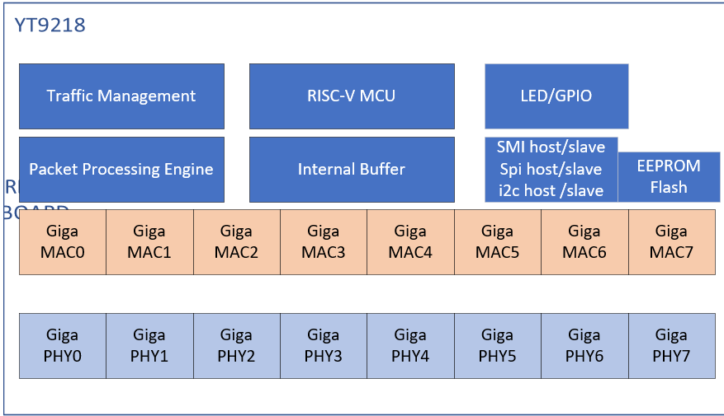

Hardware
YT9218N can replace RTL8370N-VB,precautions for hardware replacement are as follow:

Power supply
YT9218N：AVDDH/DVDDIO supply 3.3V from external power.
DVDDL/AVDDL/PLLVDDL_0/PLLVDDL_1 supply 1.1V from external power.

RTL8370N-VB: AVDDH/DVDDIO supply 3.3V from external power.
DVDDL/AVDDL/PLLVDDL_0/PLLVDDL_1 supply 1.1V from external power.

Power on strapping
Reserved pin.
Pin67 | Pull up 4.7K resistance to DVDDIO.
Pin68 | Pull up 4.7K resistance to DVDDIO.
Pin79 | Pull up 4.7K resistance to DVDDIO.

Define switch core ID, ID = {SWITCH_ID_1,SWITCH_ID_0}
YT9218N has this feature and RTL8370N-VB does not.
Pin93 | SWITCH_ID_1
Pin87 | SWITCH_ID_0

EEPROM_mod, pin80. Both YT9218N and RTL8370N-VB have this feature.
Pull UP | EEPROM Size greater than 16Kbits
Pull Down | EEPROM Size less than or equal to 16Kbits

En_pwrlight, pin83. Both YT9218N and RTL8370N-VB have this feature.
Pull UP | Enable Power on Light
Pull Down | Disable Power on Light

Dis_mcu, pin85. Both YT9218N and RTL8370N-VB have this feature.
Pull UP | Disable Embedded MCU
Pull Down | Enable Embedded MCU

Disautoload, pin86. Both YT9218N and RTL8370N-VB have this feature.
Pull UP | Disable EEPROM/FLASH autoload
Pull Down | Enable EEPROM/FLASH autoload

MID29, pin89. Both YT9218N and RTL8370N-VB have this feature.
Pull UP | MII Management Interface PHY ID is 29(0x1d)
Pull Down | MII Management Interface PHY ID is 0

En_phy, pin91. Both YT9218N and RTL8370N-VB have this feature.
Pull UP | Enable Embedded PHY
Pull Down | Disable Embedded PHY

Define smi_sel, Selection = {SMI_SEL_1,SMI_SEL_0}
Both YT9218N and RTL8370N-VB have this feature,but when smi_sel value is 2’b11, YT9218N is YT IIC mode,RTL8370N-VB is RTL IIC mode.
Pin88 | SMI_SEL_1
Pin94 | SMI_SEL_0

EN_EEE, pin90. Both YT9218N and RTL8370N-VB have this feature.
Pull UP | Enable 802.3az EEE.
Pull Down | Disable 802.3az EEE.

Dis_lpd, pin72. YT9218N has this feature and RTL8370N-VB does not.
Pull UP | Disable Loop detection function.
Pull Down | Enable Loop detection function.

Dis_led,pin75. YT9218N has this feature and RTL8370N-VB does not.
Pull UP | Disable LED function when powered on.
Pull Down | Enable LED function when powered on.

En_flash,pin84. Both YT9218N and RTL8370N-VB have this feature.
Pull UP | Enable FLASH interface.
Pull Down | Disable FLASH interface.

Power on sequence

Parameter | SYM | Description/Condition | Type | Min | Typical | Max | Units
Reset Delay Time | t1 | The duration from ‘all power steady’ to the reset signal released to high. | I | 0 | - | - | ms
Reset Low Time | t2 | The duration of reset signal remaining low time before issuing a reset to the YT9218N. | I | 10 | - | - | ms
VDDL Power Rise Time | t3 | VDDL power rise time.(10%-90%) | I | 0.5 | - | - | ms
VDDH Power Rise Time | t4 | VDDH power rise time.(10%-90%) | I | 0.5 | - | - | ms

Others
- The main functions compared with RTL8370N-VB are as follow:
P/N | YT9218N | RTL8370N-VB
Product modality | 8*GPHY | 8*GPHY
GE PHY | 8 ports | 8 ports
LUT | 4K | 4K
Jumbo | 9K | 9K
LED | Parallel&Serial | Parallel&Serial
CSD | support | support
EEE | support | support
Green | support | support
Flow Control | support | support
Micro Processor | RISC -V | 8051
Process | 55nm | NA
Package | LQFP 128 | LQFP 128

- YT9218N E-PAD is 7.15mmX6.55mm, RTL8370MB E-PAD is 6.60mmX6.60mm. Direct replacement does not affect usage.

- YT9218N pin65 has the function of dying gasp by resistance partial voltage. RTL8370N-VB pin65 is GPIO.

Power Consumption Information
YT9218N:
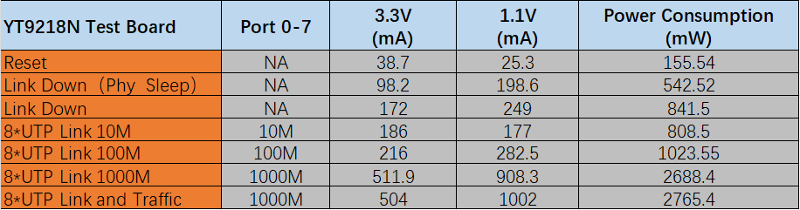

RTL8370N-VB,no detailed data description is provided in this Datasheet.

Software
SMI Slave：
The form is as follow.
PRE | 32’b1
ST | 2’b01
OP | Write:2’b01  Read:2’b10
PHY ADDR[4:0] | When mid29 = 0, PHY ADDR = 0  When mid29 = 1, PHY ADDR = 29
REG ADDR | [4] : 1‘b0  [3:2] : Switch ID  [1] : ADDR/DATA, 0: ADDR, 1: DATA  [0] : W/R, 0:W,1:R
TA | 2’b10
DATA | FRAME0:  [15:0] : PADDR[31:16]  FRAME1:  [15:0] : PADDR [15:0]  FRAME2:  [15:0] : DATA [31:16]  FRAME3:  [15:0] : DATA[15:0]

Example MDIO frame of access register.
MID29=0,Write Switch 1, PADDR: 0x1213_3434,DATA: 0x9876_5432
Using Clause 22 frame format, we need to send 4 MDIO frame:
- Write the high word of 32 bit address
- Write the low word of 32 bit address
- Write the high word of 32 bit data
- Write the low word of 32 bit data

IIC Slave：
The 7-bit address of IIC slave is 0x5c (YT9218N IIC address:0x5c).
The write operation frame format show below :

The read operation frame format show below:

Thermal Resistance Information
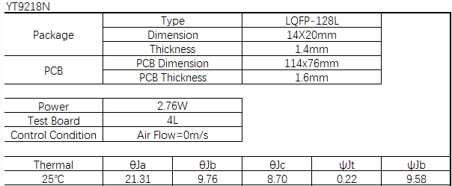

Known Problem Specification
Nothing.

